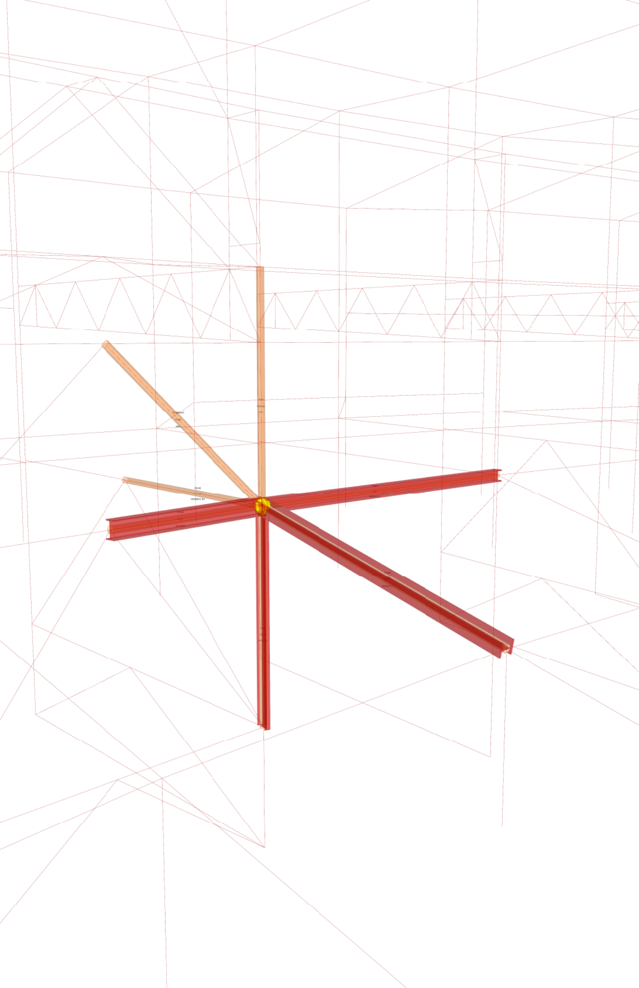TT CORE Studio

TT Toolbox Primer Sixth Edition for version 0.9.0075+

**Introduction**

In the summer of 2011, Thornton Tomasetti formed the Advanced Computational Modeling Group, which recently evolved into the CORE studio. The primary goals of CORE are to develop new workflows and processes with regards to BIM and information exchange to enhance collaboration. One of CORE studio’s roles is to educate and assist, providing project specific support along with client and in-house training. CORE studio’s work is leveraged in all of Thornton Tomasetti’s practices – structure, skin, performance, construction support services, sustainability, and property loss consulting. We split our time between R&D activities and project-specific work.

The TT Toolbox is a series of components developed to support our workflows within grasshopper. The release of TT Toolbox and the companion Primer present a sampling of custom tools we have found helpful and efficient in day to day use. The components included in the TT Toolbox are documented in the primer along with sample Rhino and Grasshopper files demonstrating their functionality.

Cheers!

TT CORE studio, Thornton Tomasetti

http://core.thorntontomasetti.com

Copyright Thornton Tomasetti, Inc.

**Table of Contents**

1 Introduction

2 Getting Started

3 TT Toolbox Components

3.1 TT Tools

TT Sweep

TT Sweep Names

Match Tree Structure

Tree Branch Index

Tree Item Index

Curve Type

Get Geometry Attributes

Remove Duplicate Points

Remove Duplicate Lines

Sort Curves by Direction

Shared Nodes

Unit converter

Safe Delete

CAD Exporter

Galapagos Listener

Brute Force Solver

Unfold

3.2 TT Excel

Write to Excel

Write Options

Read Excel Worksheet

~~3.3 Google Sheets Tools~~ * no longer supported

3.4. Dashboard

Graph

Legend _ Gradient

Legend _ Stepped

Text Display

Text Options

3.5. World Cup 2014 Brazil

Soccer Clubs

Soccer Teams

Soccer Players

4 Help

5 Revisions

**Getting Started**

TT Toolboxis designed for compatibility with Grasshopper version 0.9.0061 or higher. Make sure that you have the correct versions installed prior to installing TT Toolbox.

**Installation**-follow the directions below:

-Copy the TT Toolbox folder into your Grasshopper Components Folder.

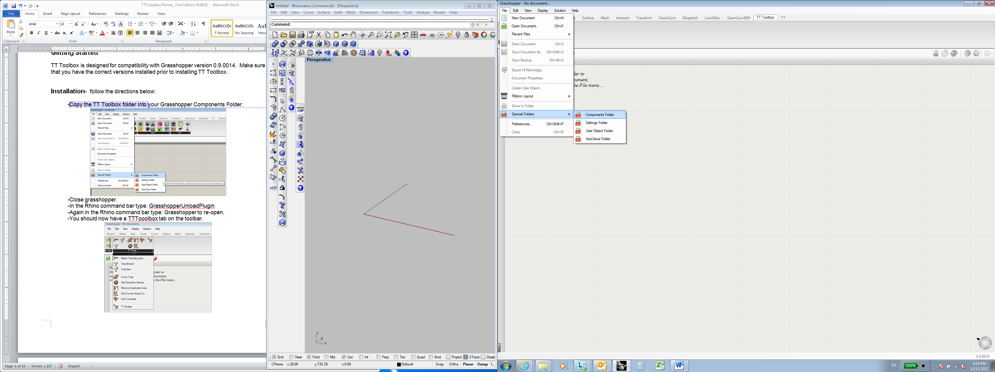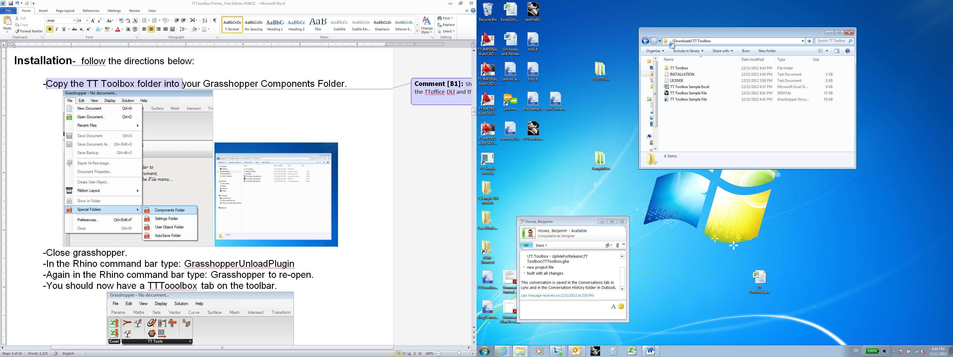

-Close grasshopper.

-In the Rhino command bar type: GrasshopperUnloadPlugin

-Again in the Rhino command bar type: Grasshopper to re-open.

-You should now have a TT Toolbox tab on the toolbar.

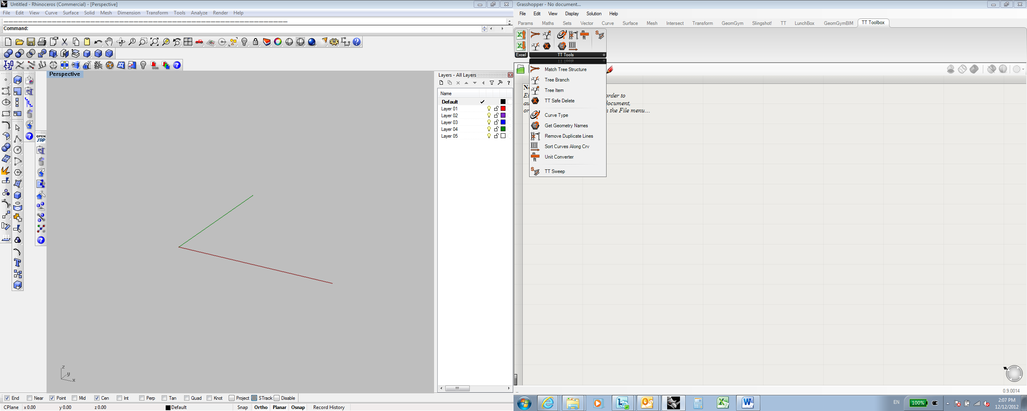

**TT Sweep** (TTSweep)

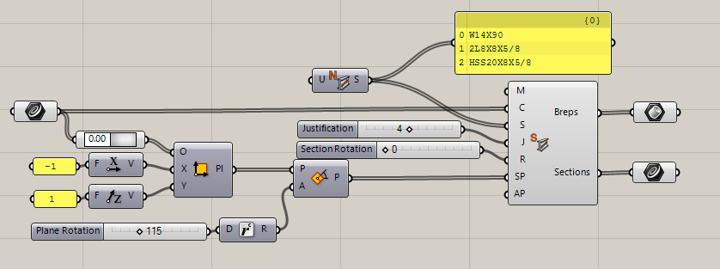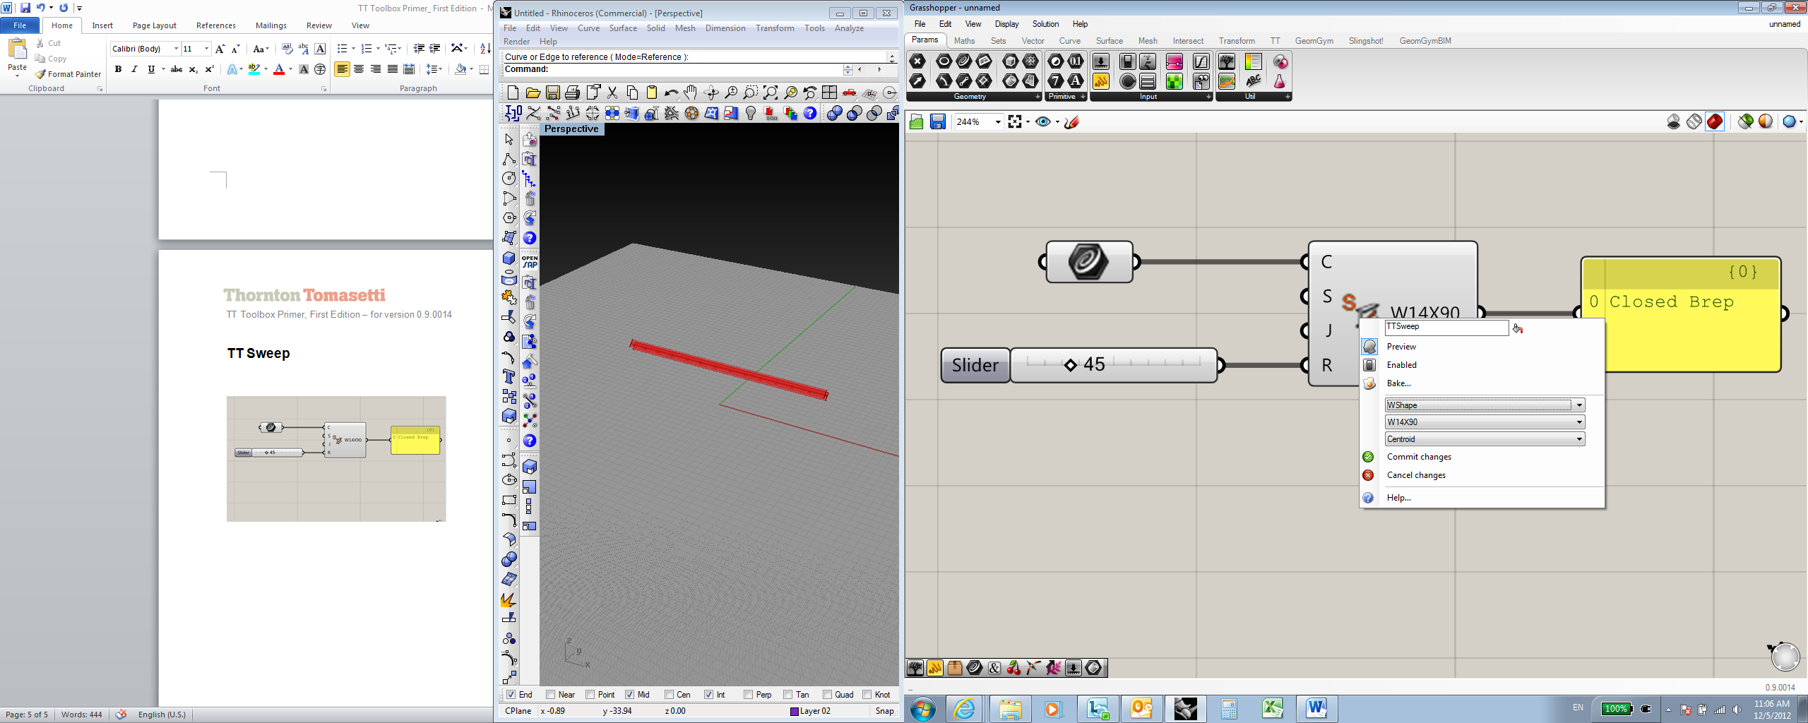****

***Inputs:***

**M** –Output Mesh? Set True for Mesh, False for Brep

**C** – Beam centerline: Input should be a curve – lines work best.

**S** – Section Name: *Right Click on component for dropdown options*

OR set section as a string in a list

**J** – Justification: Integer or use *dropdown options* to set beam(s) justification on the centerline

**R** – Beam Rotation: Degree of rotation

**SP** – Section plane to draw profile on

**AP** – Alignment plane: the cross section X axis is aligned to this plane

***Outputs:***

***Breps***– Outputs a closed Brep or Mesh

***Sections***- Outputs a profile curve

***About***:

TT Sweep outputs closed Brep or Mesh sweeps of *Structural Members* along a curve centerline input. Steel section shapes, justification to centerline, rotation around the centerline may all be controlled by the embedded catalog of options accessible by *Right Clicking* the center of the component. Alternatively, each input may be set with the appropriate components upstream. Note: if setting ‘S’ input with a string, the name must match the catalog *exactly* (i.e. W16X89, *not* W16x89 or w16X89). If SP or AP is not set, the Brep will be oriented according to industry standard structural member orientation rules.

**TT Sweep Names** (TTSweepNames)

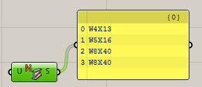

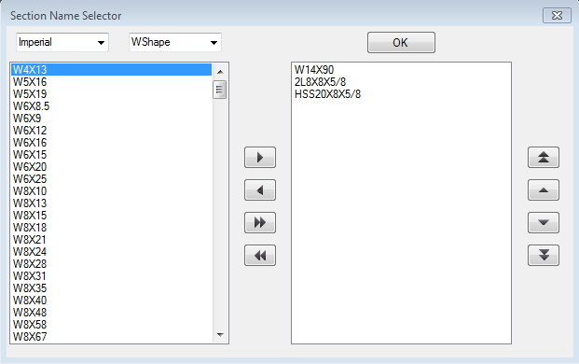

***Inputs:***

**U** – User Strings:

***Outputs:***

***Section Names***– Outputs section strings in a list

***About***:

TT Sweep Names stores and outputs common structural sections names for use with the TT Sweep component (or however you’d like). The component contains the names of the common sizes in the imperial steel sections catalog: W Shape, M Shape, S Shape, HP Shape, Cchannel, MCChannel, Angle, WTShape, MTShape, STShape, HSSTube, HSSPipe, Pipe, LLShape. User specific strings can also be provided – they show up in the user string list in the dropdown.

To select shapes from the list, right click the component, click on the ‘Section Selector’ command, and use the controls on the form to populate an output list.

**MatchTree Structure** (Match)

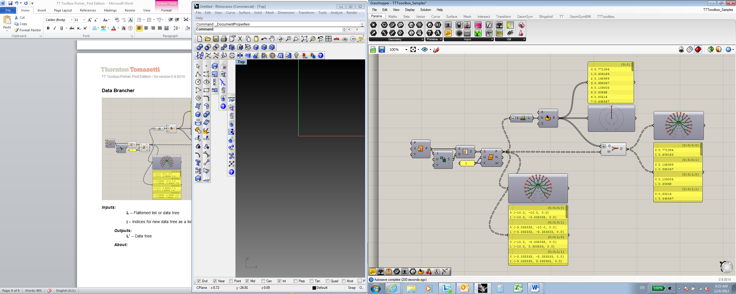

***Inputs:***

**D** – Data list to convert to tree structure

**M** – Tree Mask: tree structure to apply Data list to

***Outputs:***

**D’** – New Data tree

***About:***

This component takes two inputs: a flat list of N data items, and a data tree containing N data items arranged in any arbitrary tree structure. The output is the flat list reconfigured to match the path structure of the input list. This is very useful for data matching. This component was originally developed as a cluster by Andrew Heumann and published on the Grasshopper forum.1

1:http://www.grahopper3d.com/profiles/blogs/data-tree-utilities-match-path?xg_source=activity

**Tree Branch** (TB)

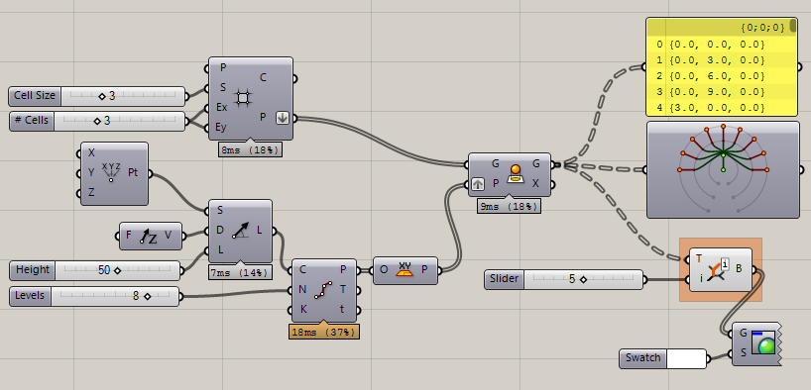 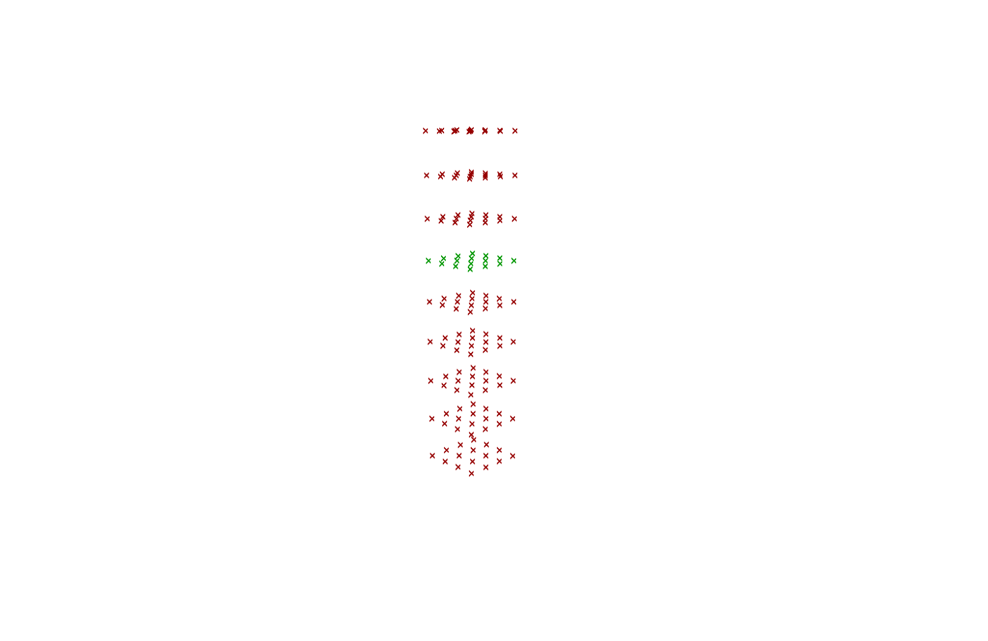

8

7

6

1

2

3

4

**5**

0

***Inputs:***

**T** – Data tree

**i** – Branch index

***Outputs:***

**B** – Branch items

***About:***

This component will retrieve all items in a specified tree branch index from a data tree. Grasshopper provides a component like this that requires a path as an input. This component instead requires an integer, and retrieves the corresponding branch from a tree, where the first tree branch = 0, the second = 1, etc. This is useful in debugging and/or survey stages of a project when it is necessary to visualize which data belongs to which branch, and to see how the branches are ordered in 3d.

**Tree Item** (Ti)

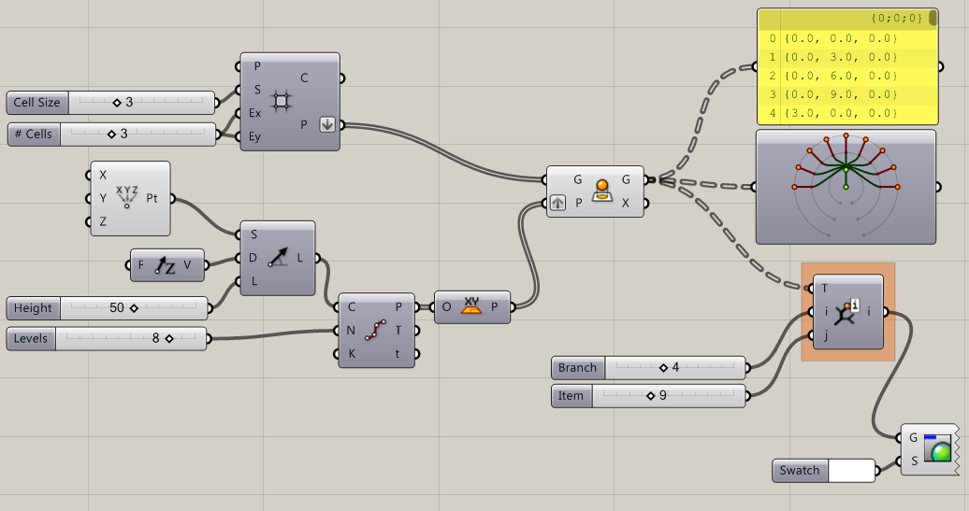 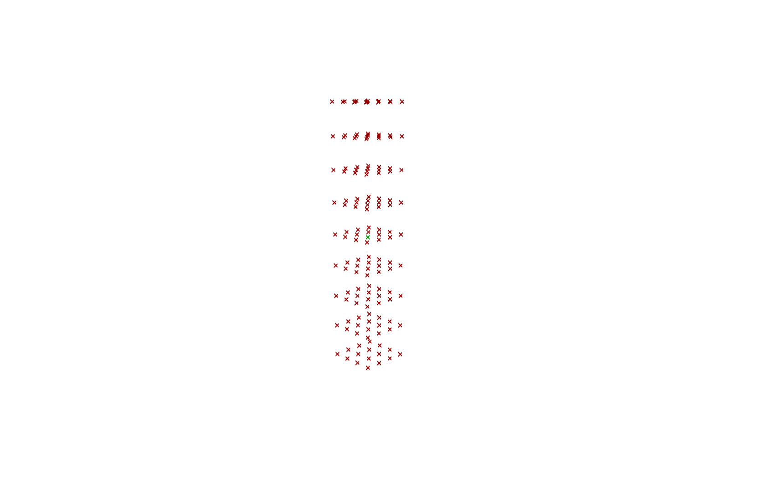

0

1

2

3

**4**

5

6

7

8

**9**

***Inputs:***

**T** – Data tree

**i** – Branch index

**j** – Item index

***Outputs:***

**i** – Specific item

***About:***

This component will retrieve a specified item from a specified branch in a data tree. It behaves similarly to the Tree Branch component in how it accesses branches from a tree, and retrieves only the requested item (using a zero based index) from the requested tree. Again, this is useful for debugging and 3d data visualization.

**Curve Type** (CT)

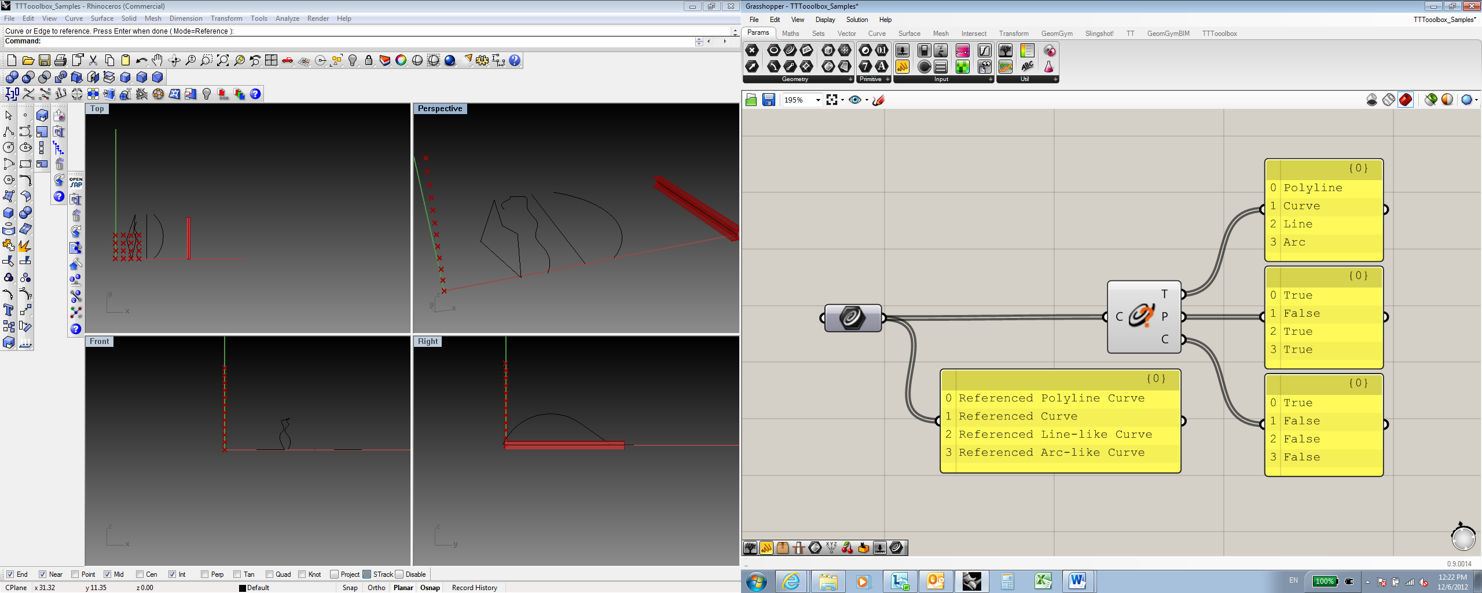

***Inputs:***

**C** – Curve

***Outputs:***

**T** – Curve Type as string

**P** – Is curve planar?: returns a Boolean value

**C** – Is curve closed?: returns a Boolean value

***About:***

This component inputs a generic curve(s) and outputs the type as a string and whether it is planar or not and if it is closed or not as separate Boolean value outputs. This tool is helpful for debugging and culling out curve types within a larger set.

**Get Geometry Attributes** (GeoAttrib)

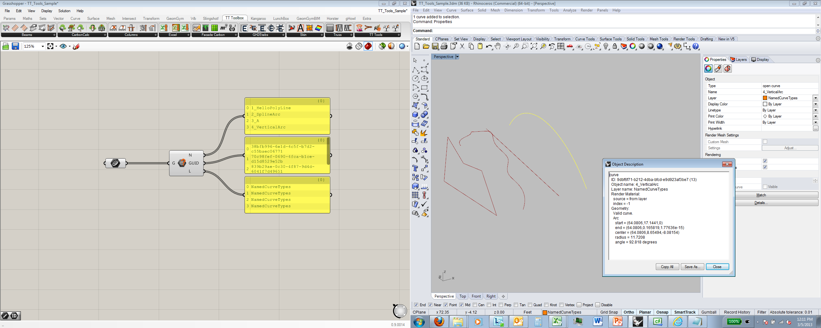

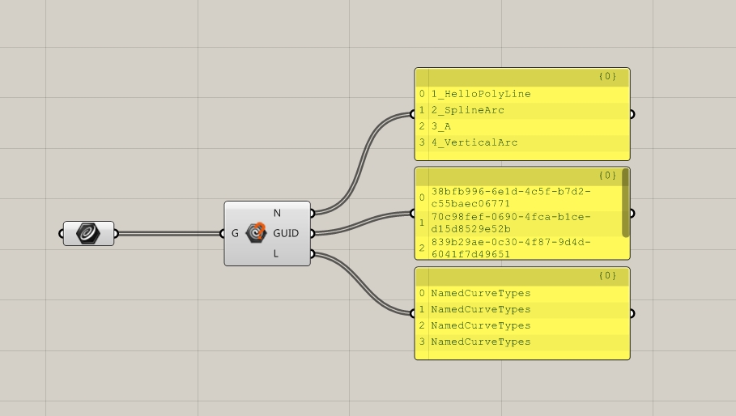

***Inputs:***

**G** – Geometry

***Outputs:***

**N** – Name: as a string

**GUID** – GUID for each item

**L**- Layer of each item as a string

***About:***

This component inputs generic geometry referenced from Rhino and outputs the name of the object as per specified in Rhino. The GUID and Layer of the object are also output. Note: if changing names in Rhino, you will need to re-connect the input for the new names to update in the component.

**Remove Duplicate Points** (CullDupPoints)

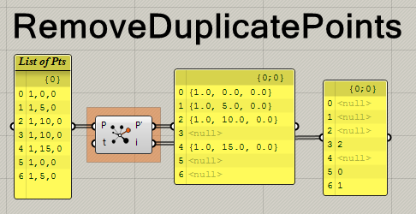

***Inputs:***

**P** – List of points

**t** – Tolerance for equality check.

***Outputs:***

**P’** – List of points without duplicates

**i** – List of Indexes of the first instance of the duplicate line[s].

***About:***

This component takes a list of points and removes all duplicates. Nulls are added to the P’ output list where duplicates were found. Use the i output to find out where duplicates are in a list.

**Remove Duplicate Lines** (CullDupLines)

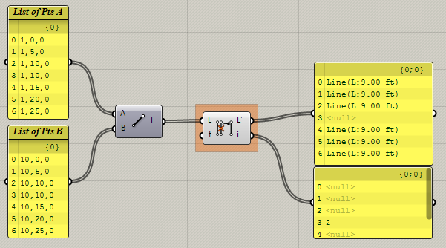

***Inputs:***

**L** – List of lines

**t** – Tolerance for equality check.

***Outputs:***

**L’** – List of lines without duplicates

**i** – List of Indexes of the first instance of the duplicate line[s].

***About:***

This component takes a list of lines and removes all duplicates. Nulls are added to the L’ output list where duplicates were found. Use the i output to find out where duplicates are in a list.

**Sort Curves Along Curve** (SortC)

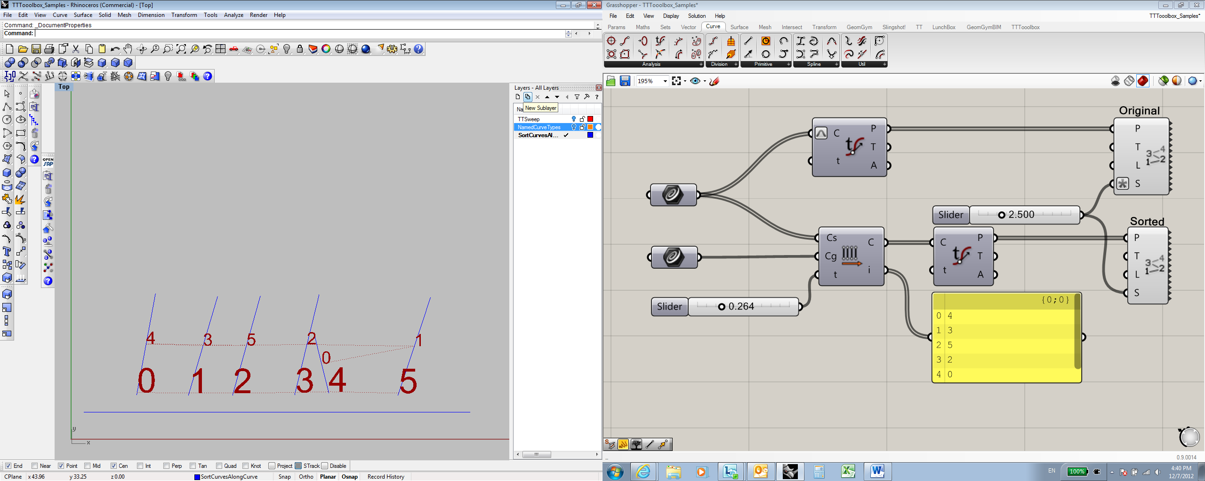 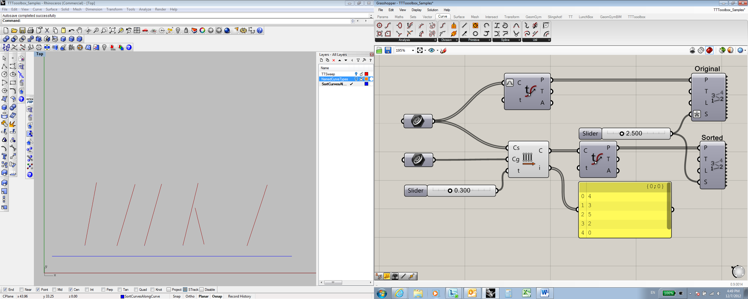

“t” input specifies location on curve for evaluation

***Inputs:***

**Cs** – Curves to be sorted

**Cg** – Guide Curve

**t** – Location on curve to sort distance evaluation

***Outputs:***

**C** – Sorted Curves

**i** – Index of curves after sorting

***About:***

This component will sort a list of curves using a guide curve to define a direction. The component is based on a solution provided by David Rutten on the Grasshopper discussion boards.2 This is useful when you need to sort an unsorted 2d array of curves by both X and Y values.

2http://www.grasshopper3d.com/forum/topics/sort-mesh?commentId=2985220%3AComment%3A197801

**Shared Nodes** (NodeConn)

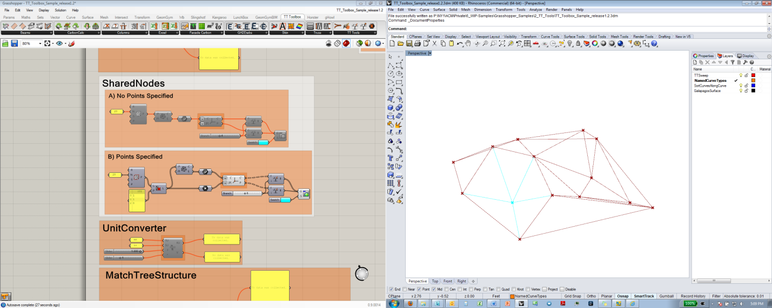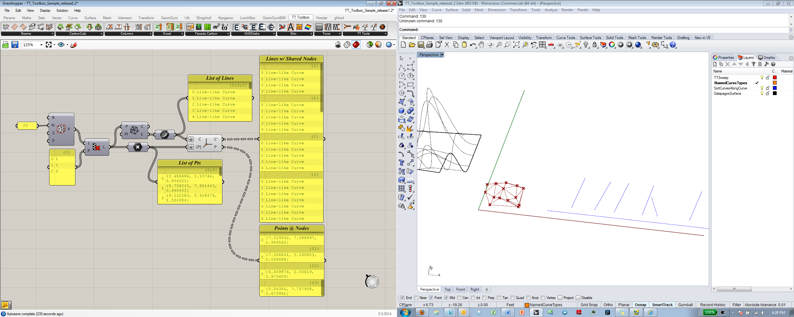

***Inputs:***

**C** – Curves to be grouped, as a flat list

**[P]** – Optional Node points, as a flat list

***Outputs:***

**C’** – Data tree with a branch containing all curves sharing a node

**P** – Data tree of node points

***About:***

This component takes a flat list of curves and creates a data tree where each branch contains all curves that share a node (start or end point). If the optional [P] input receives a list of node points, the data tree will be organized according to the input points. If [P] does not receive an input the node points are created by extracting all start and end points and removing all duplicates.

**Unit Converter** (UC)

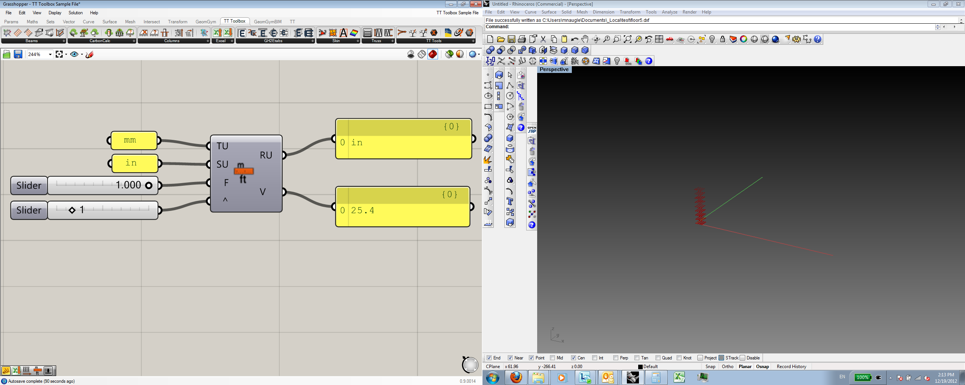

***Inputs:***

**TU** – Target Units: mm, cm, m, in, ft

**SU** – Source Units: mm, cm, m, in, ft

**F** – Factor: value to convert

**^** – Exponent: requires an integer; 1= linear, 2= squared; 3= cubed

***Outputs:***

**RU** – Current Rhino units

**V** – Converted unit value

***About:***

This component converts basic distance units: millimeters, centimeters, meters, inches, and feet. The component also returns the units of the Rhino model *when Grasshopper is first loaded*. If the units in Rhino are changed, you will need to unload and reload grasshopper for the RU output to update.

**TT Safe Delete** (TTSafeDelete)

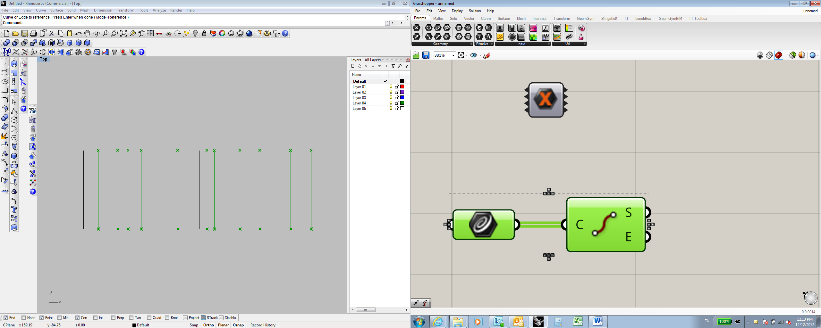 

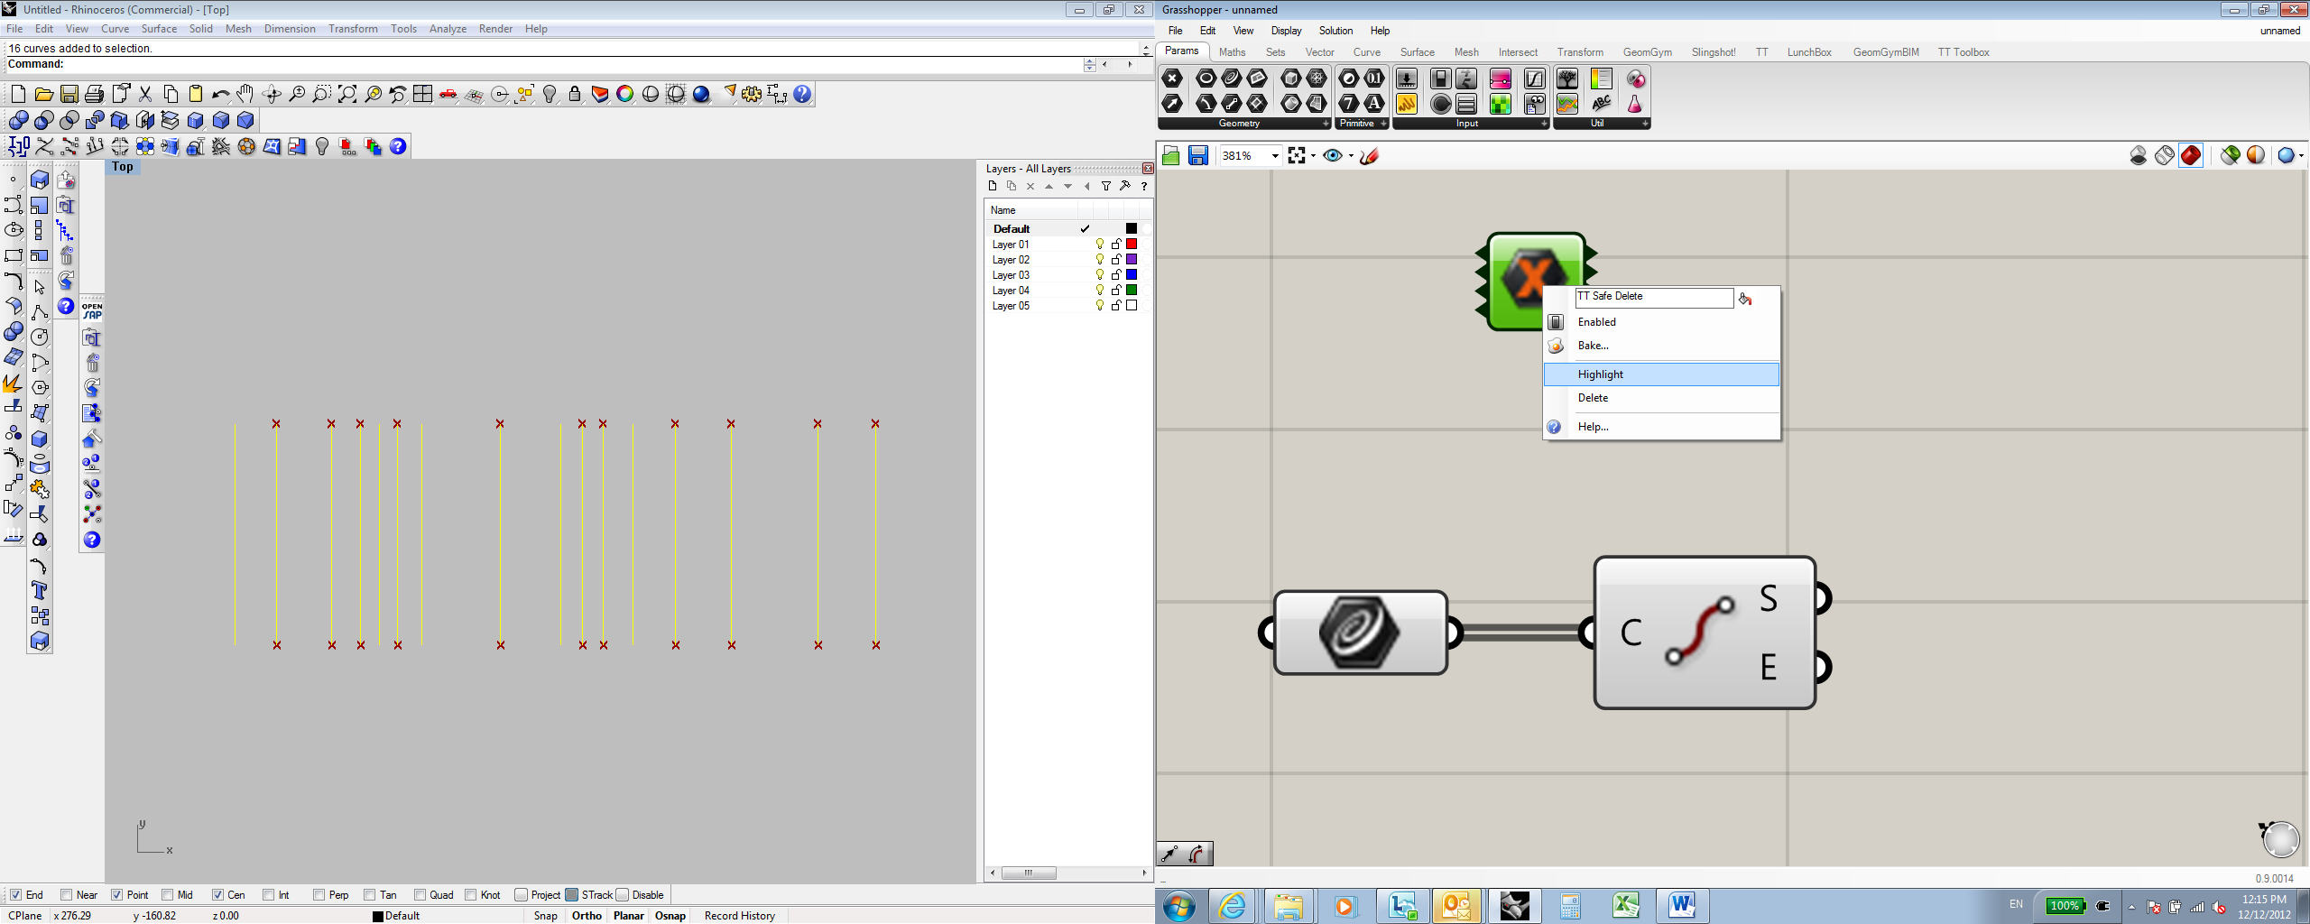 

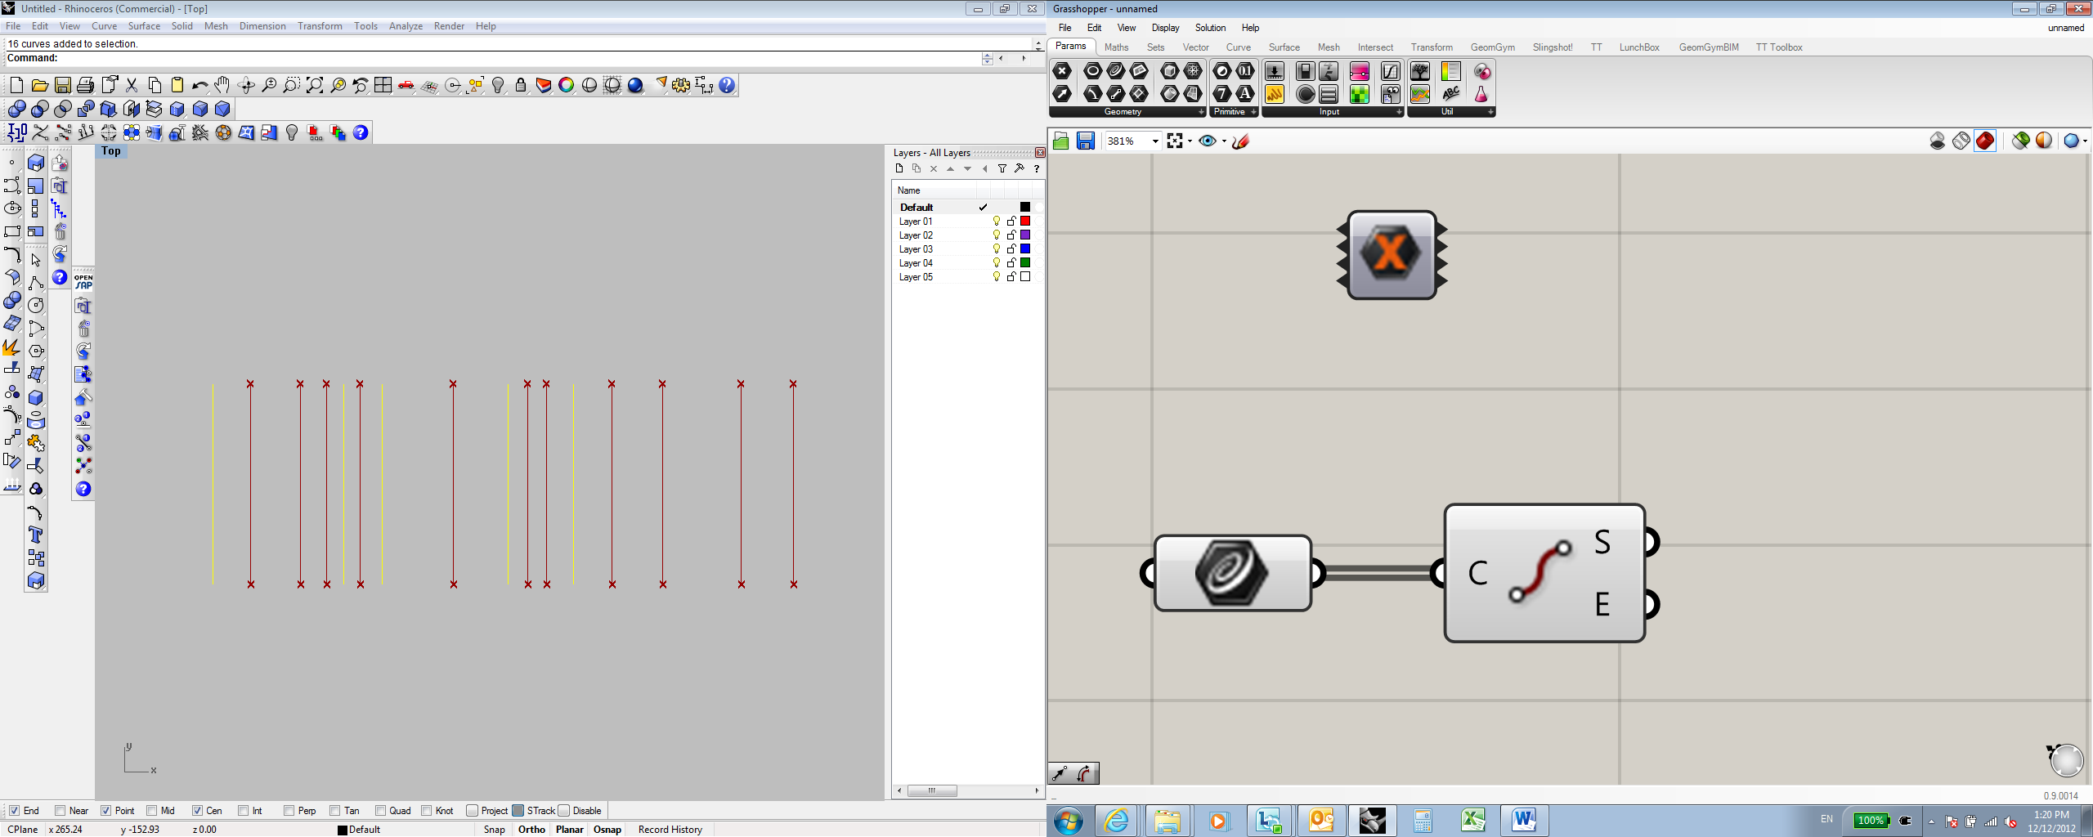

***About:***

This component allows you to select Rhino geometry then cull out any geometry from that selection that is referenced into Grasshopper. The component is helpful for cleaning up Rhino files of unnecessary geometry without accidentally deleting, moving, or altering referenced geometry.

***How it works:***

Select all geometry in Rhino -> *Right Click* on the component -> choose *Highlight*. This will de-select all Rhino geometry that is referenced into Grasshopper while keeping the remaining unreferenced geometry in Rhino selected.

**CAD Exporter** (CADExporter)

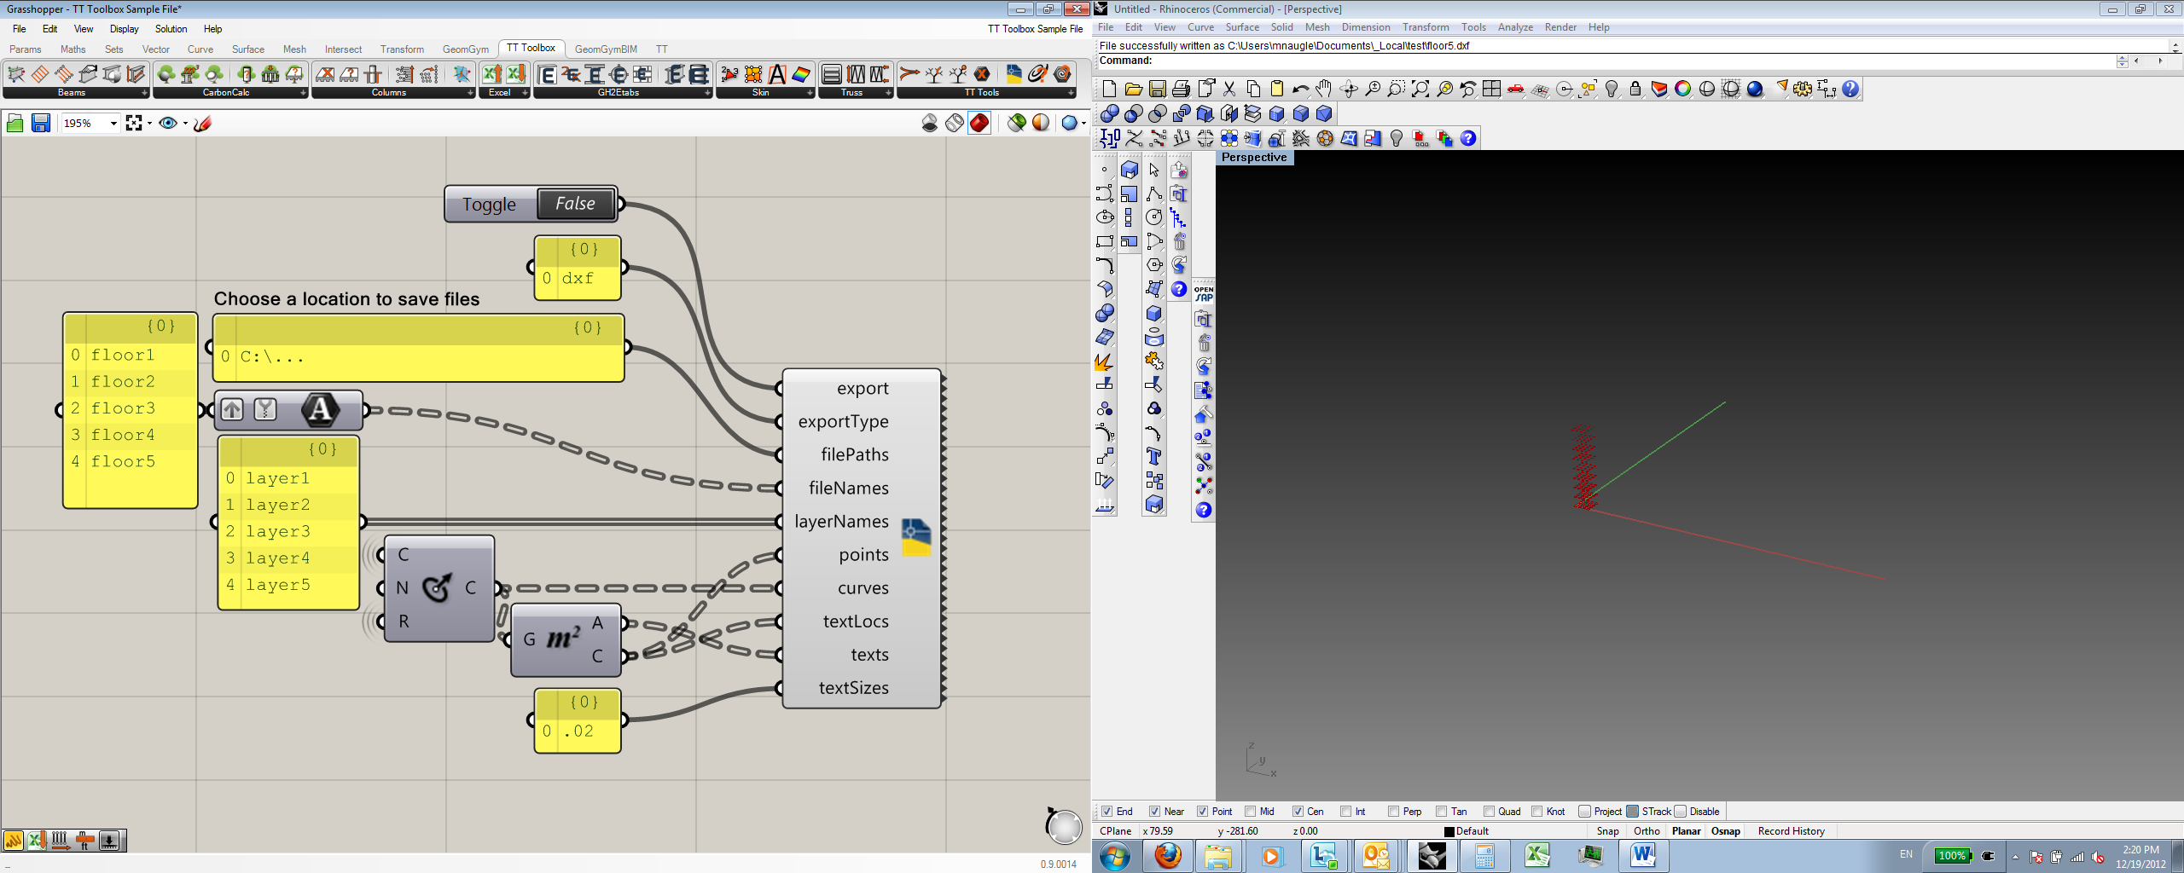 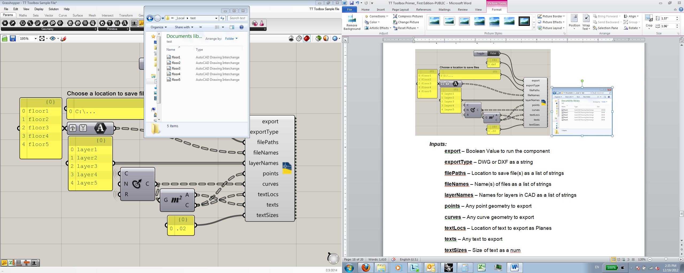

***Inputs:***

**export** – Boolean Value to run the component

**exportType** – DWG or DXF as a string

**filePaths** – Location to save file(s) as a list of strings

**fileNames** – Name(s) of files as a list of strings

**layerNames** – Names for layers in Rhino as a list of strings

**points** – Any point geometry to export

**curves** – Any curve geometry to export

**textLocs** – Location of text to export as Planes or Points

**texts** – Any text to export

**textSizes** – Size of text as a num

***About****:*

This component will export Point and Curve geometry directly as a DWG or DXF file. The component enables individual tree branches to be exported as separate CAD files allowing for efficient use of complex data organization.

**Galapagos Listener** (GalapList)

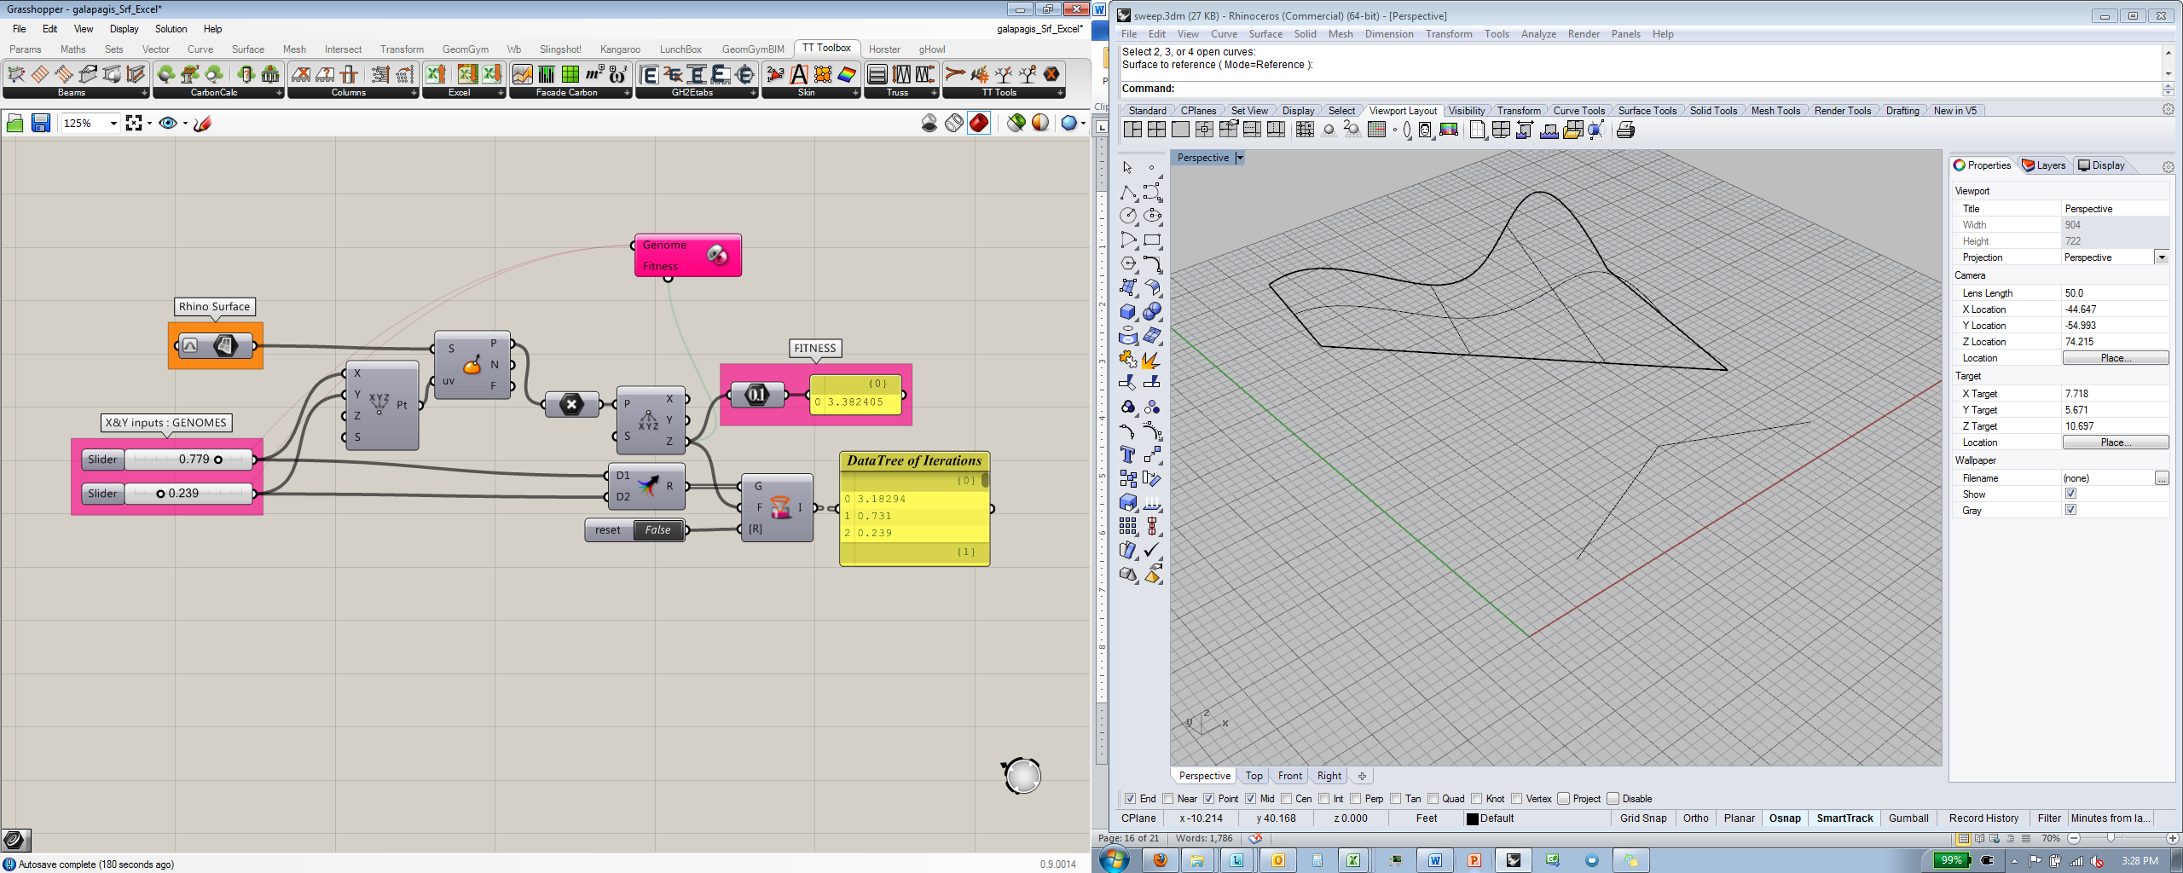

***Inputs:***

**G –** Genomes as input to Galapagos

**F –** Fitness as input into Galapagos

**[R] –** Reset as a Boolean to clear the record

***Outputs:***

**F** – Data tree of Fitness values

**I** – Data tree of input genomes

***About:***

This component will write a branch with each iteration of a Galapagos or Brute Force run. To clear the data tree between writes, toggle the R input.

*Please note: the R input must be set to FALSE in order to record.*

**Brute Force Solver** (Brute Force)

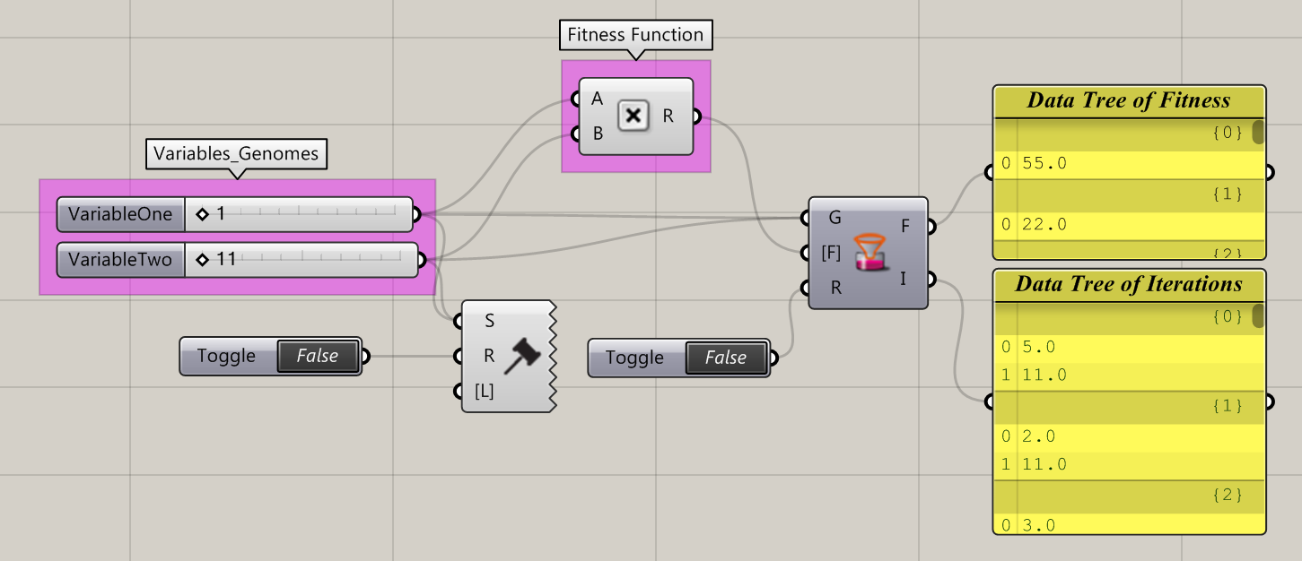

***Inputs:***

**S –** List of number sliders

**R –** Run the solver? If true, solving routine will run

**[L] –** Maximum number of combinations allowed

***About:***

This component will take control of the grasshopper canvas, and generate every possible combination of [input] slider values when it runs. It’s sort of like Galapagos, except it has no goal – it will just try everything! Use this to iterate through all options in your design space, and our Galapagos Listener component to measure the fitness of each genome. Make sure to set the ‘R’ toggle to false immediately after the component runs – in this release, any subsequent action on the GH canvas will trigger another brute force solve – we’ll fix this in a future release.

**Write To Excel** (WriteXL)

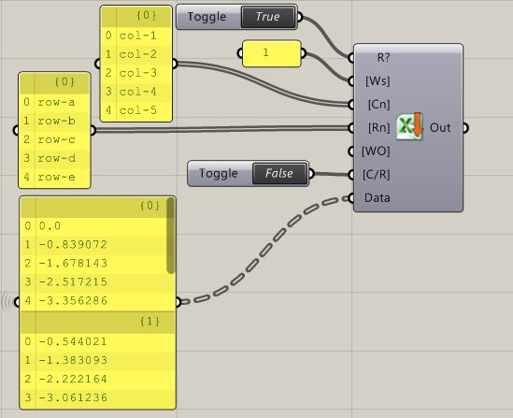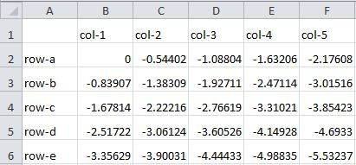

***Inputs:***

**R?** – Boolean Value to write data to Excel, clears all data on toggle

**[Ws]** – 1 based integer or string of worksheet name: *integer(s) or string(s)*

**[Cn]** – Column names as a list: *string(s)*

**[Rn]** – Row names as a list: *string(s)*

**[WO]** – Write Options: *string*

**[C/R]** – Boolean Value for writing data as columns or rows

**Data** – Data to write to excel

***Outputs:***

**Out** – User messages for debugging

***About:***

This component will write each branch of data in a data tree as a column or row in Excel. Each time the component runs with the default settings, it clears all data from the designated worksheet and writes a new set of data. Be sure to back up your work and use a new worksheet when using this component. The ‘Out’ parameter provides some limited user feedback. See the Write Options component (next page) for some additional options when writing data to excel.

**Write Options** (WO)

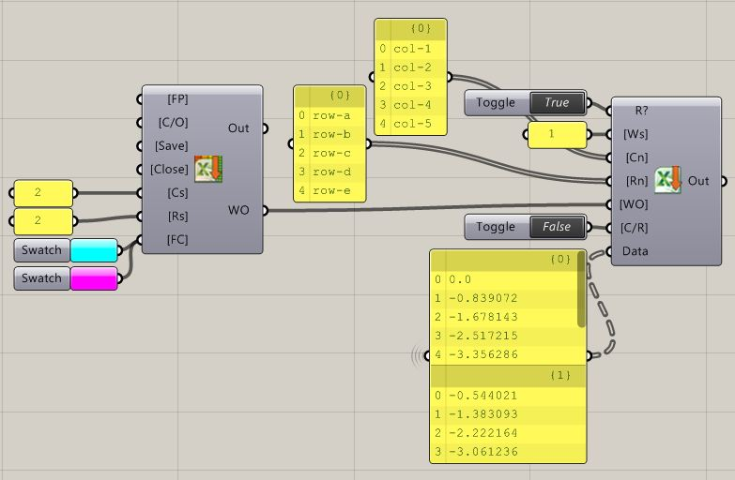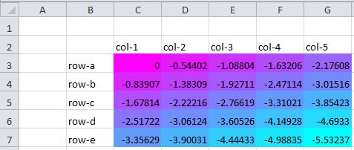

***Inputs:***

**[FP]** – File path to open or save: *string*

**[C/O]** – Boolean toggle to clear entire sheet or overwrite cells: *boolean*

**[Save]** – Save document after write?: *boolean*

**[Close]** – Close document after write?: *boolean*

**[CS]** – Column to start writing in: *integer*

**[RS]** – Row to start writing in: *integer*

**[FC]** – List of colors to define conditional formatting range in excel: *Colors*

***Outputs:***

**Out** – User messages for debugging

**WO** – Write options string to plug into Write to Excel component

***About:***

This component compiles a Write Options string that can be used by the Write To Excel component to customize the way you write data into excel. Users may specify the position to start writing data in, if the file should be saved and/or closed after writing, and whether or not they would like conditional formatting to be applied to the data after it has been written to excel (using user defined colors).

**Read Excel Sheet** (ReadXL)

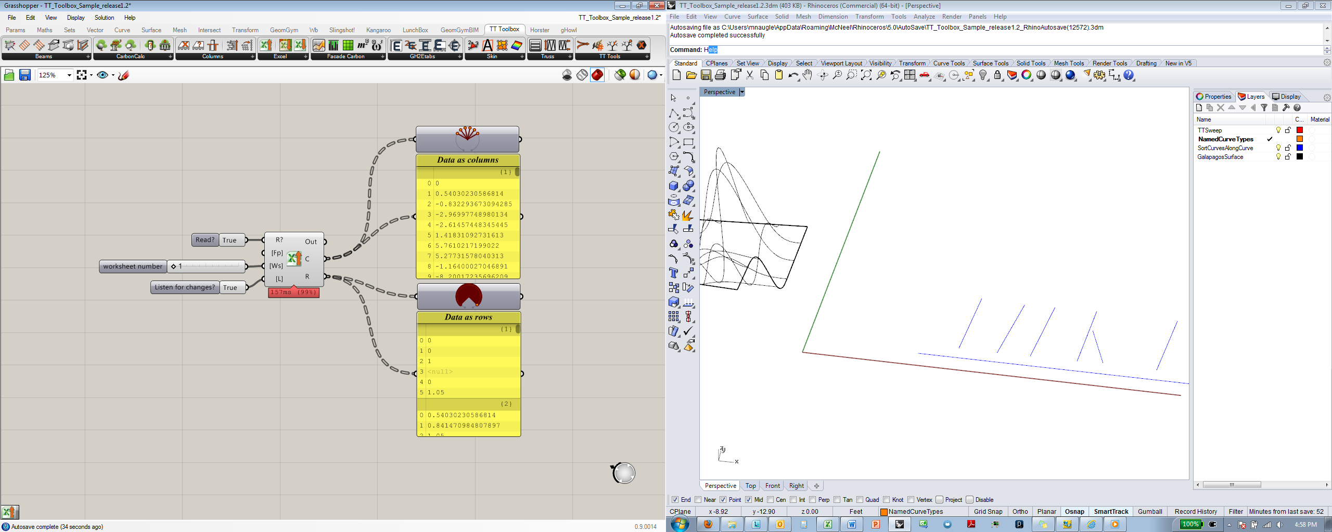 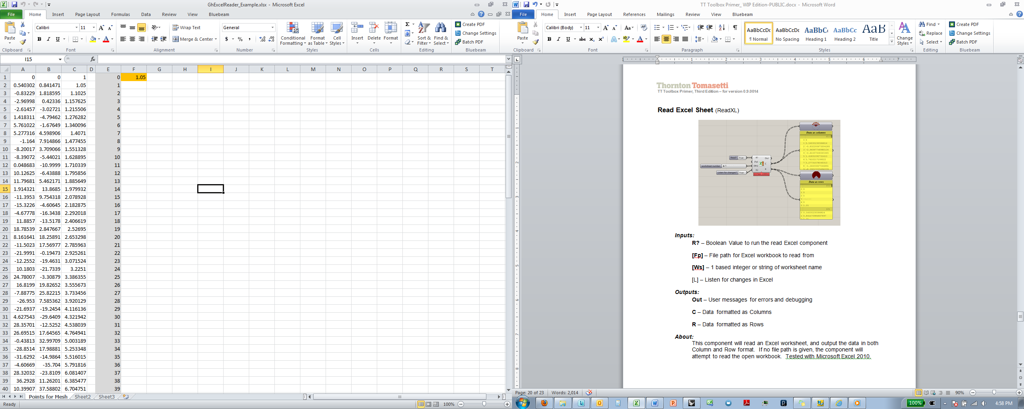

***Inputs:***

**R?** – Boolean Value to run the read Excel component

**[Fp]** – File path for Excel workbook to read from

**[Ws]** – 1 based integer or string of worksheet name

**[L]** – Listen for changes in Excel

***Outputs:***

**Out** – User messages for errors and debugging

**C** – Data formatted as Columns

**R** – Data formatted as Rows

***About:***

This component will read an Excel worksheet, and output the data in both Column and Row format. If no file path is given, the component will attempt to read the open workbook. The optional [L] input when toggled True will listen for any changes made in the active worksheet and dynamically update in Grasshopper. Tested with Microsoft Excel 2010.

*Note: For Listener- R? & [L] should be set to false, then toggle R? true, followed by [L]*

**Google Credentials** (GoogleCredentials)

This component is no longer supported. Please refer Leafcutter plug-in for Google Sheets interoperability.

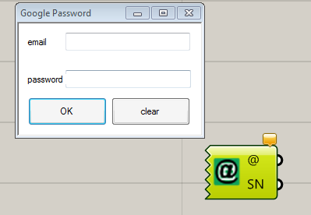

***~~Inputs:~~***

~~Right Click > Enter Google Credentials or DoubleClick~~

***~~Outputs:~~***

**~~@ –~~** ~~email address~~

**~~SN –~~** ~~Spreadsheet names~~

***~~About:~~***

~~This component will connect to your google account and output a list of available sheets from your Google Drive.~~

**Get Google Worksheets** (getWorksheets)

This component is no longer supported. Please refer Leafcutter plug-in for Google Sheets interoperability.

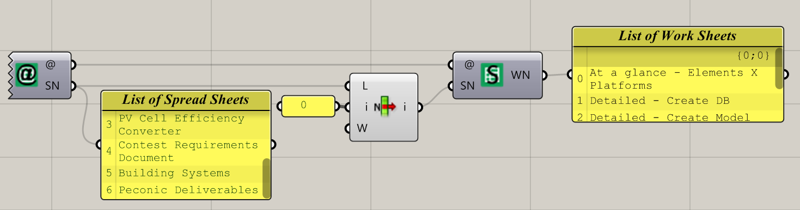

***~~Inputs:~~***

**~~@ –~~** ~~google account address~~

**~~SN –~~** ~~Spreadsheet Name~~

***~~Outputs:~~***

**~~WN–~~** ~~Worksheet Names~~

***~~About:~~***

~~This component will get a list of all the worksheets from a spreadsheet in Google Drive.~~

**Read Google Worksheet** (getWorksheets)

This component is no longer supported. Please refer Leafcutter plug-in for Google Sheets interoperability.

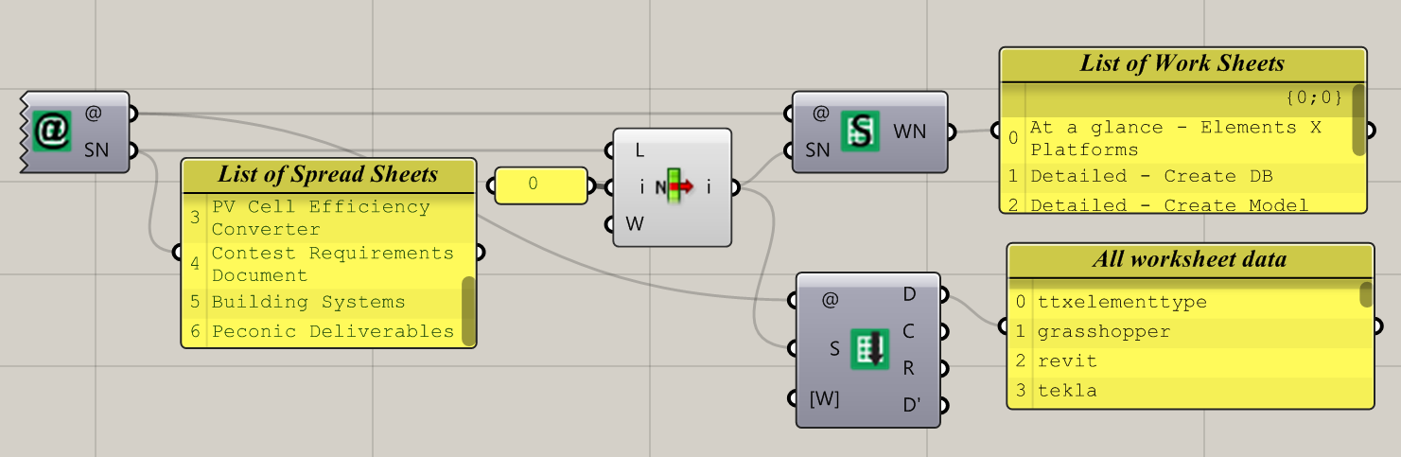

***~~Inputs:~~***

**~~@ –~~** ~~google account address~~

**~~SN –~~** ~~Spreadsheet Name~~

**~~[W] –~~** ~~Worksheet Name~~

***~~Outputs:~~***

**~~D –~~** ~~All worksheet data~~

**~~C –~~** ~~Column Names~~

**~~R –~~** ~~Row Names~~

**~~D’ –~~** ~~Culled worksheet data – no header~~

***~~About:~~***

~~This component will output a data tree of all the data in a Google worksheet, where every column of data in the sheet is returned as a branch of the data tree.~~

**Unfold**

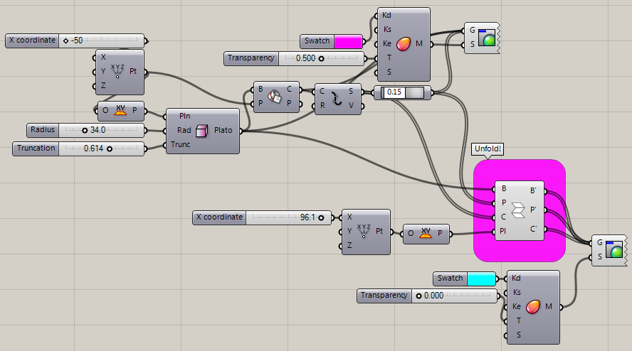

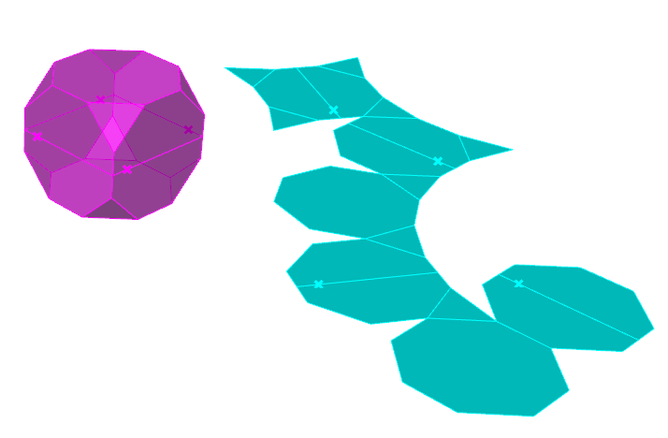

***Inputs:***

**B –** A brep to unfold

**P –** List of points on brep

**C –** List of curves on brep

**Pl –** Plane. Default WorldXY plane

***Outputs:***

**B’ –** The unfolded brep

**P’ –** The unfolded points

**C’ –** The unfolded curves

***About:***

This component will unfold/unroll a developable input brep, along with any input points and/or curves that are on the brep, onto a user-defined target plane.

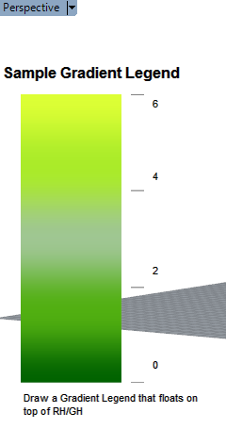**Legend_Gradient**

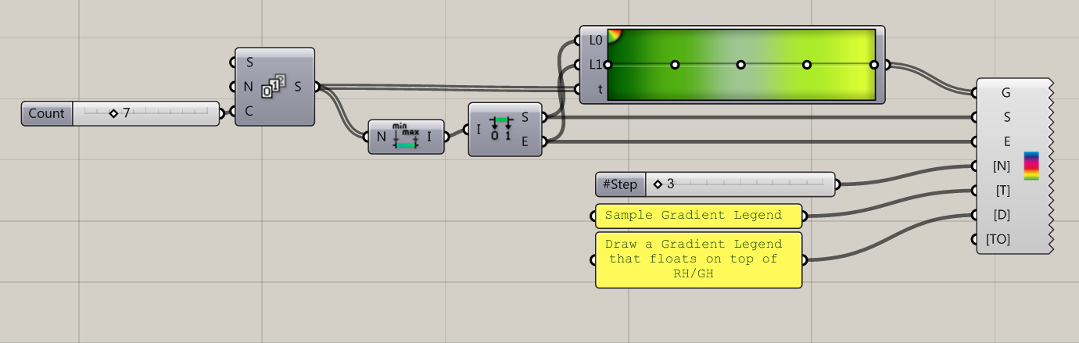

***Inputs:***

**G–** A gradient component

**S –** Start of domain (min) of legend

**E –** End of domain (max) of legend

**[N] –** Number of steps to display between start and end domains

**[T] –** Title of the Legend

**[D] –** Description of the Legend

**[TO] –** Text options parameter to control Legend’s text settings.

***About:***

This component will draw a Legend (as a transparent Windows-style window – you can move it, scale it, etc.) on top of Rhino and Grasshopper. Use this to help visualize color-coded data in Grasshopper.

To move or edit the size of the legend, double click on the colored portion of the legend. To leave the editing mode, single click the colored portion.

To hide/show the legend, right click the component and click Preview ON/OFF

**Legend_Stepped**

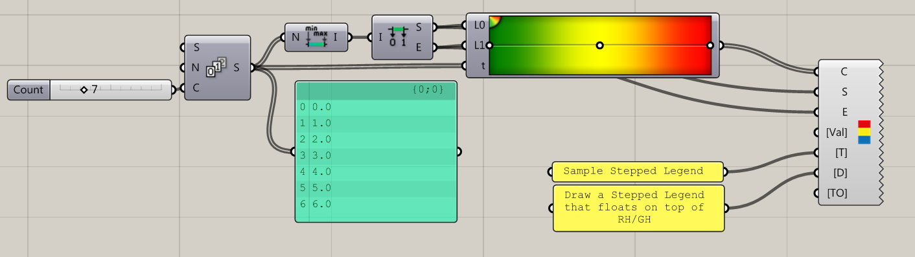

***Inputs:***

**C –** a list of color values

**S –** Start of domain (min) of legend

**E –** End of domain (max) of legend

**[Val] –** Values to display next to each step. Optional

**[T]–** Title of the Legend

**[D] –** Description of the Legend

**[TO] –** Text options parameter to control Legend’s text settings.

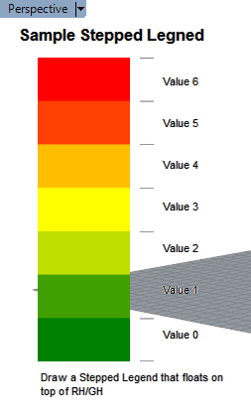

***About:***

This component will draw a Stepped Legend (as a transparent Windows-style window – you can move it, scale it, etc.) on top of Rhino and Grasshopper. Use this to help visualize color-coded data in Grasshopper.

To move or edit the size of the legend, double click on the colored portion of the legend. To leave the editing mode, single click the colored portion.

To hide/show the legend, right click the component and click Preview ON/OFF

**Graph**

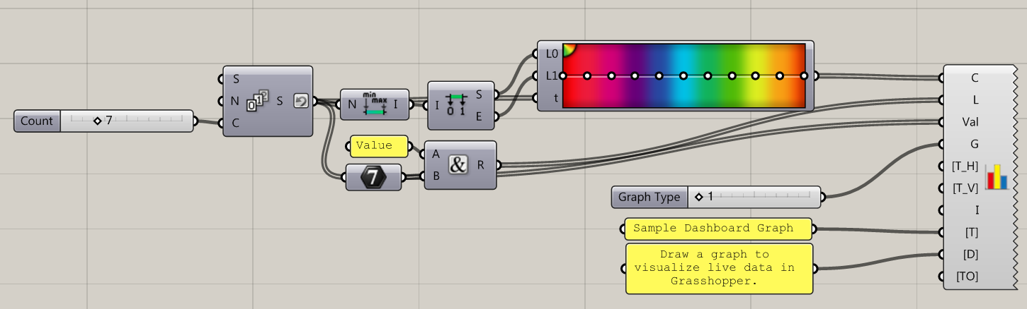

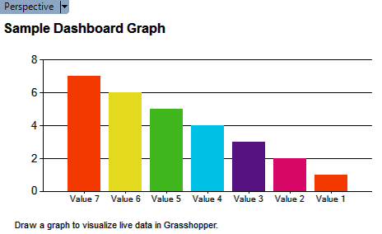***Inputs:***

**C–** a list of color values

**L–** a list of titles – one per color

**Val –** a list of numeric values to graph

**G_** The type of graph to draw. 1:Column, 2:Point; 3:Line; 4:Pie; 5:Doughnut

**[T-H] –** Title of the X axis of a graph

**[T-V] –** Title of the Y axis of a graph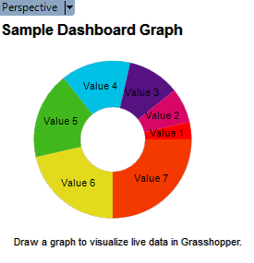

**I _** Domain:Set bounds of thegraph

**[T]–** Title of the Graph

**[D] –** Description of the Graph

**[TO] –** Text options parameter to control Graph’s text settings.

***About:***

This component will draw a Graph (as a transparent Windows-style window – you can move it, scale it, etc.) on top of Rhino and Grasshopper. Use this to help visualize numeric data in Grasshopper.

To move or edit the size of the legend, double click on the colored portion of the legend. To leave the editing mode, single click the colored portion.

To hide/show the legend, right click the component and click Preview ON/OFF

**Text Display**

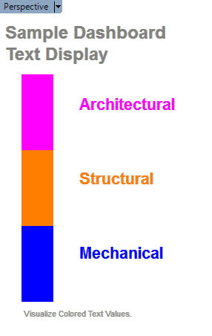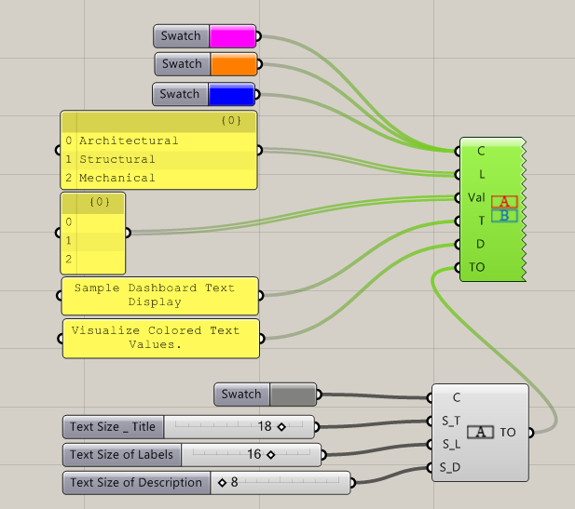

***Inputs:***

**C –** a list of color values

**L –** a list of titles, labels – one per color

**Val –** a list of values – one per color

**[T] –** Title of the Graph

**[D] –** Description of the Graph

**[TO]–** Text options parameter to control Graph’s text settings.

***About:***

This component will draw a Color Key (as a transparent Windows-style window – you can move it, scale it, etc.) on top of Rhino and Grasshopper. Use this to help visualize colored geometry in Grasshopper.

To move or edit the size of the legend, double click on the colored portion of the legend. To leave the editing mode, single click the colored portion.

To hide/show the legend, right click the component and click Preview ON/OFF

**Text Options**



***Inputs:***

**C –** Color of text elements in dashboard windows

**S-T –** Size of the Title

**S-L –** Size of the Labels

**S-D –** Size of the Description

***Outputs:***

**Text Options –** Text options parameter to use downstream.

***About:***

This component configures text options to use in other dashboard components. Use this to set the font, style, and sizes of the text elements of dashboard generated text.

To access font and style options, right click on the component and select ‘Text Fonts’ from the context menu.

**Soccer Clubs**

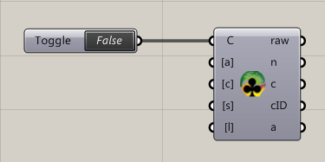

***Inputs:***

**C –** Boolean. Set ‘True’ to Connect

**[a] –** attribute[s] to retrieve

**[c] –** country filter

**[s] –** sort attribute[s]

**[l] –** limits the number of inquiry

***Outputs:***

**raw –** returns a JSON array containing club objects

**n –** Name of soccer clubs

**c –** Country of soccer clubs

**cID –** Club IDs

**a –** Filtered attributes

***About:***

This component retrieves and parses the raw official data about specific club teams around the world.

The attributes of the Club objects: name, country, address, stadium name, stadium address, stadium Image, stadium Image, stadium capacity, founded year, id, type

For more info about the data go here: <http://www.kimonolabs.com/worldcup/explorer>

**Soccer Teams**

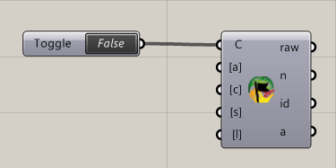

***Inputs:***

**C –** Boolean. Set ‘True’ to Connect

**[a] –** attribute[s] to retrieve

**[c] –** country filter

**[s] –** sort attribute[s]

**[l] –** limits the number of inquiry

***Outputs:***

**raw –** returns a JSON array containing team objects

**n –** Name of soccer teams

**cID –** Club IDs

**a –** Filtered attributes

***About:***

This component retrieves and parses the raw official data about specific soccer teams participating in 2014 World Cup

The attributes of the Team objects: name, logo, website, founded year, address, home stadium, stadium capacity, group, group rank, group points, matches played, wins, losses, draws, goals for, goals against, goals Diff, id, type.

For more info about the data go here: <http://www.kimonolabs.com/worldcup/explorer>

**Soccer Players**

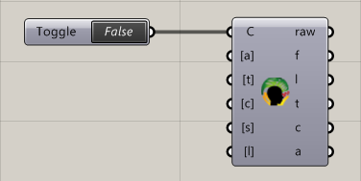

***Inputs:***

**C –** Boolean. Set ‘True’ to Connect

**[a] –** attribute[s] to retrieve

**[t] –** team filter

**[c] –** country filter

**[s] –** sort attribute[s]

**[l] –** limits the number of inquiry

***Outputs:***

**raw –** returns a JSON array containing player objects

**f –** First name of player

**l –** First name of player

**t–** Team id

**c–** Club id

**a –** Filtered attributes

***About:***

This component retrieves and parses the raw official data about specific soccer players participating in 2014 World Cup

The attributes of the Players objects: first name, last name, nick name, nationality, age, birth date, birth country, birth City, position, foot, image, height, weight, goals, own goals, penalty goals, assists, team id, club id, id, type.

For more info about the data go here: <http://www.kimonolabs.com/worldcup/explorer>

**Help**

For more information visit: **http://core.thorntontomasetti.com**

**http://grasshopper3d.com/group/corestudio**

**http://food4rhino.com/project/tttoolbox**

**Revisions**

Second Edition:

-Added Excel Write Options component

-Revised functionality to Excel Writer component

Third Edition:

-GetGeometryNames replaced with GetGeometryAttributes

-Revised functionality of TTSweep to include profile outputs & plane inputs

-Added Galapagos Listener component

-Added Shared Nodes component

-Added Listener function to Excel Reader

Fourth Edition:

-Added Brute Force solver

-Revised Galapagos Listener outputs

-Added Google Sheets components

Fifth Edition – 1.5, 1.5.1:

-Added Unfold component

-Added Dashboard data visualization components

-Various bug fixes and improvements

Sixth Edition – 1.6

-Added World Cup Brazil 2014 Components

-Improved Dashboard data visualization components

-Removed Google Sheets Components

-Improved TT Sweep and TT Sweep Names component: mesh, and metric section catalog support

-Various bug fixes and improvements